SIMATS ENGINEERING
ASSESSMENT TOOL III — TIME-SERIES & GEOSPATIAL ANALYSIS REPORT
Course: Data Handling and Visualization | Code: DSA0603 | CO: CO4
Duration: 60 min | Total Marks: 50 | Reg No: 192324275  Name: JAANA NITHISH

COURSE OUTCOME COVERED
Apply appropriate visualization techniques to analyze time series data, detect trends, seasonality, and cyclical patterns. (BL3)
CO3 Construct and interpret geospatial visualizations, including static, cartogram-based, and interactive representations. (BL3)
Activity Tool : Time-Series & Geospatial Analysis Report Weightage: 20%

Code of Conduct:
I JAANA NITHISH(192324275) certify that this submission is my original work and that I have adhered to the guidelines specified for this assessment. I understand that any violation of academic integrity rules will result in disciplinary action.

Signature of the student: JAANA NITHISH
Criteri a | Data Understand ing & Preparation 25% | Time Series/Geospa tial Analysis 25% | Applicati on of Visualizat ion Technique s 20% | Report Organizat ion 15% | Accura cy 10% | Clarity 5% | Total
Q1
Q2
Q3

Q4
Q5

Time-Series & Geospatial Analysis Report
Topics: Individual & Multiple Time Series, STL Decomposition, Smoothing & Detrending, Forecasting, Cycle/Seasonality Detection | Choropleth Maps, Cartograms, Interactive Geospatial Plots, Projections & Layers, 3D Geospatial Visualization

Note: Questions 1–4 are to be completed in R. Question 5 must be completed in Python.

Provided Datasets
The following files are supplied alongside this document. All are real, publicly documented datasets: ● Nile.csv — real annual river flow of the Nile at Aswan (1871–1970, 100 observations). ● AirPassengers.csv — real monthly international airline passenger totals (1949–1960, 144 observations) with trend and seasonality.
- USArrests.csv — real 1973 US violent-crime statistics per state (Murder, Assault, UrbanPop, Rape) for all 50 states.
- state_x77.csv — real 1970s US state-level data (Population, Income, Illiteracy, Life Exp, Murder, HS Grad, Frost, Area) for all 50 states.
- quakes.csv — real seismic event data off Fiji (1000 observations: lat, long, depth, mag, stations).
- volcano_elevation.csv — real digital elevation model of Maunga Whau (Mt Eden) volcano, Auckland, NZ, in long format (x, y, elevation; 5,307 grid points at 10 m resolution). Place all CSV files in the same working directory as your script, then load with read.csv() in R or pandas.read_csv() in Python.

Question 1: Individual Time Series — Smoothing & Detrending

Language: R
Dataset provided: Nile.csv
Convert the value column into an R ts object (start = 1871, frequency = 1) and plot the raw annual flow as a line chart. Overlay a 5-year moving-average smoother (stats::filter() or zoo::rollmean()). Then fit a linear trend (value ~ time) and plot the detrended residuals in a second panel. Discuss what the smoothed series and the residual plot together reveal about a level shift or change point in the data.
Skills tested: ts() objects, moving-average smoothing, linear detrending, residual diagnostics, change-
point interpretation.
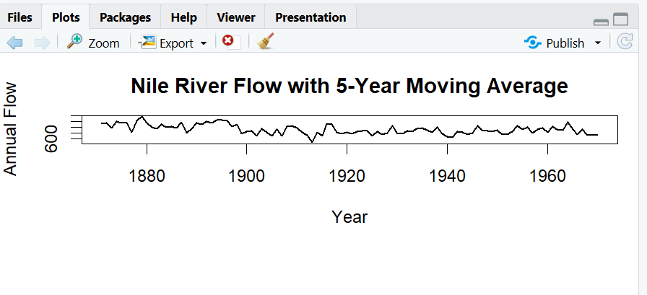

Brief interpretation
  - The 5-year moving average removes short-term fluctuations and highlights the long-term level of river flow.
  - The smoothed series shows a noticeable change in level around the late 1890s.
  - The residual plot shows unusually large deviations around this period.
  - This suggests a possible level shift/change point rather than only a simple linear trend.

Question 2: Seasonal Decomposition (STL) & Forecasting

Language: R
Dataset provided: AirPassengers.csv
Convert the passengers column into a ts object (start = c(1949,1), frequency = 12). Apply STL decomposition (stl(), s.window = "periodic") and plot the trend, seasonal, and remainder components. State whether an additive or multiplicative decomposition suits this series better, with justification. Then fit an
ETS or auto.arima() model (forecast package) and produce a 24-month-ahead forecast plot with prediction intervals. Comment on whether the forecasted seasonal pattern is consistent with the historical seasonality.
Skills tested: stl(), additive vs. multiplicative decomposition, forecast::ets()/auto.arima(), forecast intervals, seasonality validation.
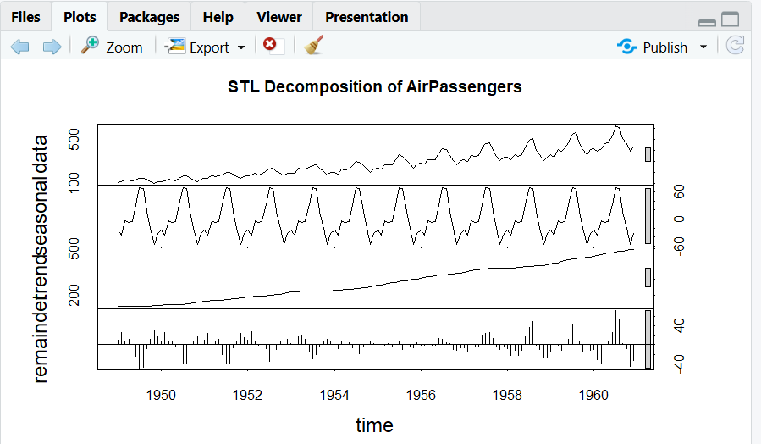

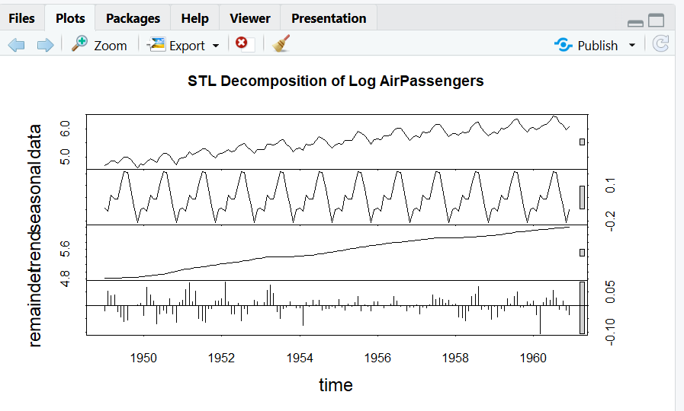
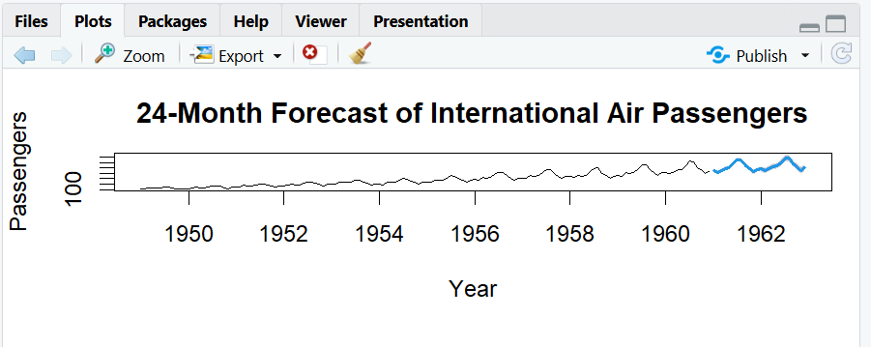

Better multiplicative decomposition
For this dataset, multiplicative seasonality is more suitable because:
  - Passenger numbers increase strongly over time.
  - Seasonal fluctuations also become larger as the overall passenger level increases.
  - The seasonal variation is therefore approximately proportional to the trend.
  - Using log(AirPassengers) makes the seasonal component more stable.

Forecast interpretation
  - The forecast continues the historical upward trend.
  - A repeating yearly seasonal pattern remains visible.
  - Passenger numbers are expected to peak during the same seasonal periods seen historically.

Question 3: Choropleth Map & Interactive Geospatial Plot This question has two parts.
Part a — Choropleth Map

Language: R
Dataset provided: USArrests.csv
Join USArrests.csv to US state boundary polygons (e.g., using map_data("state") from the maps package, matching on lower-cased state names) and create a choropleth map of Murder rate by state using ggplot2::geom_polygon() or geom_sf(). Use a sequential color scale and add a legend, title, and a brief caption. Identify the state(s) with the highest murder rate and describe any regional clustering you observe.
Part b — Interactive Geospatial Plot

Language: R
Dataset provided: quakes.csv
Using the leaflet package, plot the earthquake locations as circle markers on an interactive map, sizing each marker by mag and coloring by depth (e.g., using colorNumeric()). Add popups showing magnitude and depth on click. Briefly describe any spatial clustering of high-magnitude events.
Skills tested: geom_polygon()/geom_sf() choropleths, sequential color scales, leaflet::addCircleMarkers(), colorNumeric(), interactive popups, spatial clustering interpretation.
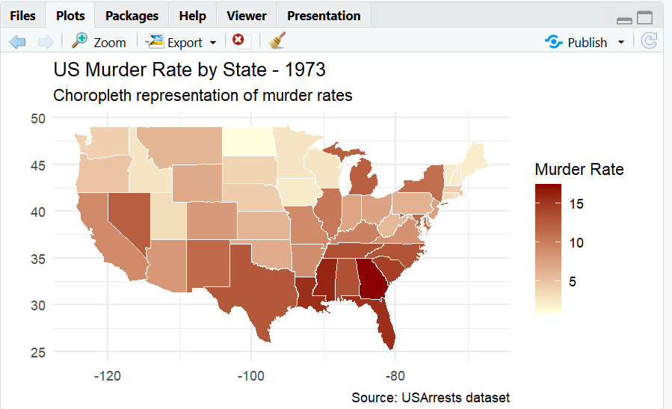
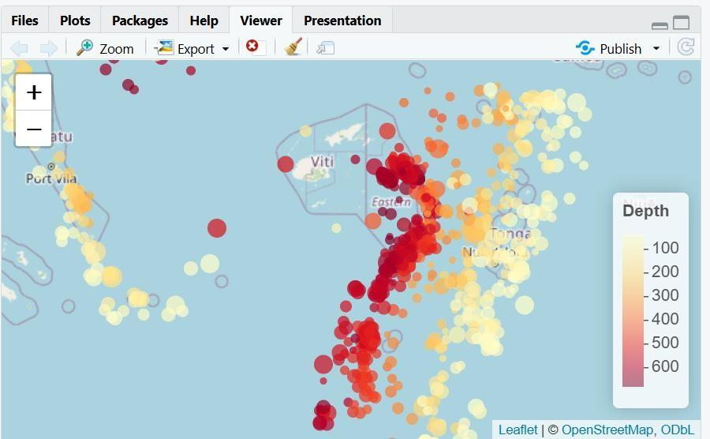

Interpretation
  - Georgia has the highest murder rate in the dataset.
  - Higher murder rates are particularly visible across parts of the Southern US.
  - The map suggests regional clustering rather than a completely random distribution.
  - Earthquakes are concentrated along a relatively narrow region around Fiji.
  - Larger circles represent higher magnitude earthquakes.
  - Deeper earthquakes are distinguished using the color scale.
  - High-magnitude events are spatially clustered rather than uniformly distributed.

Question 4: Cartogram with Map Projections

Language: R
Dataset provided: state_x77.csv (join to US state boundary polygons, e.g. via the maps package)
Join state_x77.csv to US state boundary polygons and construct a population-weighted cartogram using the cartogram package (cartogram_cont() or cartogram_ncont(), sf-based workflow), distorting each state's area in proportion to its Population. Render the cartogram alongside a standard (undistorted) choropleth of the same Population variable, using two different projections for the standard map (e.g., coord_sf(crs = ...) with an Albers equal-area projection vs. a simple longitude/latitude projection). Discuss how the cartogram changes the visual impression of which states appear "large" compared to the standard map, and how the choice of projection affects the standard map's shape.
Skills tested: sf workflows, cartogram_cont()/cartogram_ncont(), coord_sf() and projections (CRS), comparing distorted vs. true-area representations.

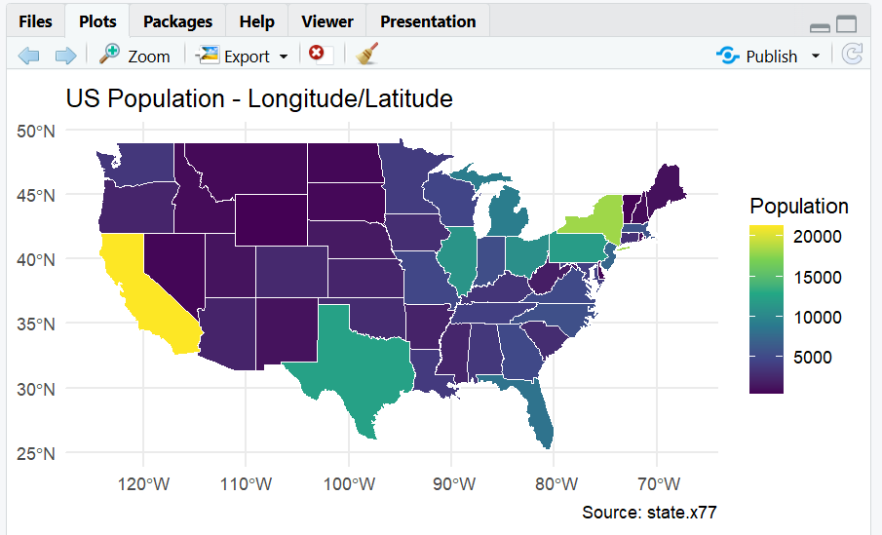
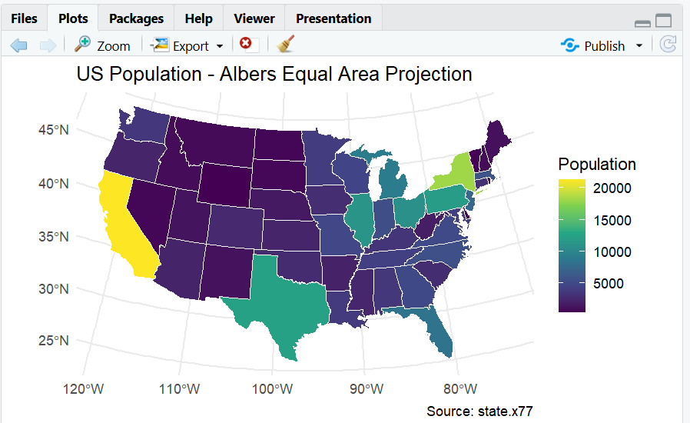

Interpretation
  - In the normal map, states such as Texas, California and Alaska appear large because of their geographic area.
  - In the population cartogram, highly populated states become visually larger.
  - Less-populated states shrink substantially.
  - The Albers equal-area projection preserves area relationships better than simple longitude/latitude display and gives a more appropriate shape for comparing US states.

Question 5: 3D Geospatial Heatmap

Language: Python
Dataset provided: volcano_elevation.csv
Load volcano_elevation.csv (columns: x, y, elevation — a 61 × 87 grid representing the Maunga Whau volcano digital elevation model). Pivot the data into a 2D elevation grid and create an interactive 3D surface heatmap using Plotly (plotly.graph_objects.Surface, with a suitable colorscale such as "Earth" or "Viridis" mapped to elevation). Add axis titles and a title, and enable hover tooltips showing elevation at each grid point. Additionally produce a 2D top-down heatmap (e.g., plotly.graph_objects.Heatmap or seaborn.heatmap) of the same data for comparison. In 2–3 sentences, discuss what the 3D surface view reveals about the volcano's shape that the 2D heatmap alone does not (or vice versa).
Skills tested: pandas pivot(), plotly.graph_objects.Surface, 3D colorscales and hover tooltips, 2D heatmap comparison, matplotlib/seaborn or plotly for 2D view.

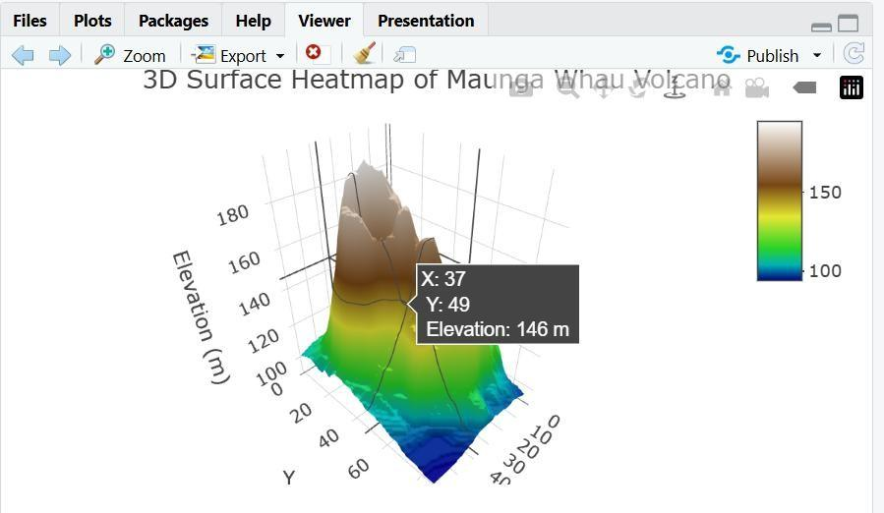
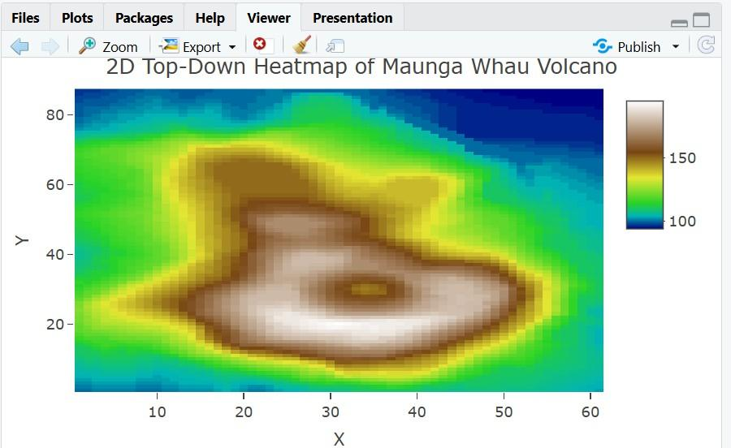
  - The 3D surface makes the volcano's peaks, slopes, ridges, and depressions much easier to recognize because elevation is represented directly as vertical height.
  - The 2D heatmap provides a clearer top-down view of the spatial distribution of elevation, but it does not communicate the steepness and relative height of the terrain as effectively as the 3D surface.

